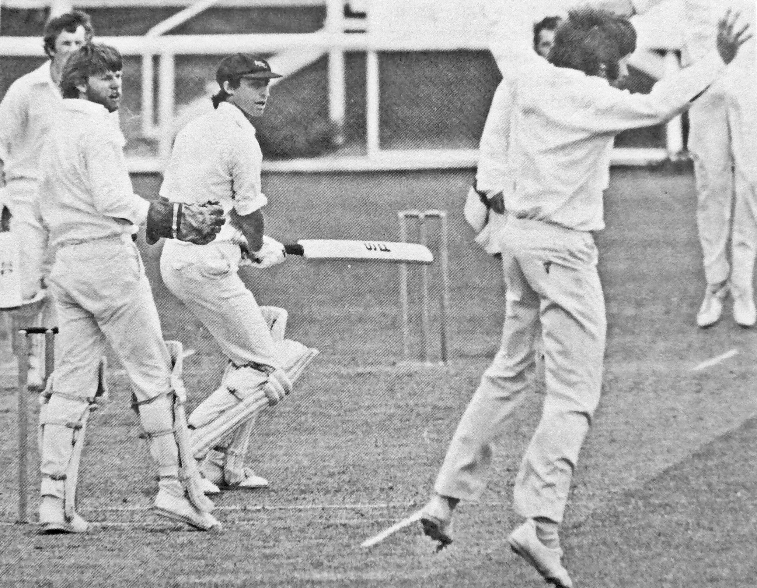

**Barry Hadlee cuts pass slip John Morrison. Allan Hewson wicket keeper**

**Canterbury v Wellington 30 December 1978 Lancaster Park**

**Canterbury 200 and 225/6 declared Wellington 164 and 265/8. Wellington won by two wickets**